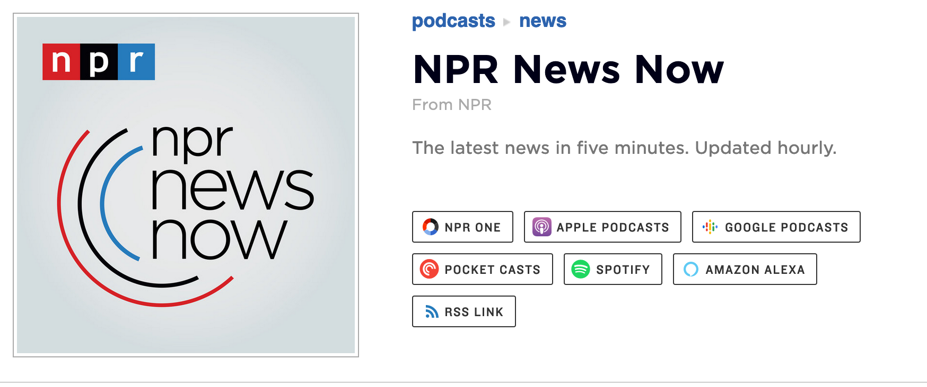

- What was the lead story and why is it important?

2. What was the next story?

3. Which stories were political?

4. What new information was provided on Covid-19?

5. What international stories were presented? Had you heard about these before? Should the mainstream media be covering these more thoroughly?


6. In your mind what was the most interesting story of the day and why?

Listen to the headline story of marketplace with Kai Ryssdal. Summarize it. Was it covered fairly in your mind? What questions did it bring up?

