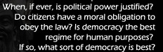
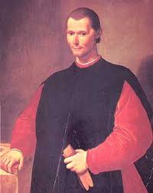
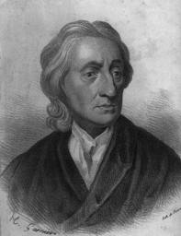
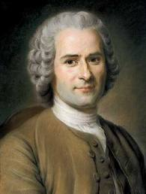
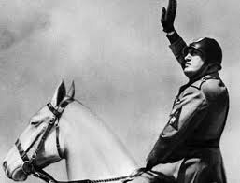
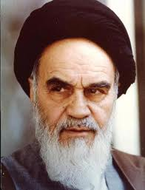
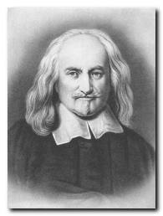
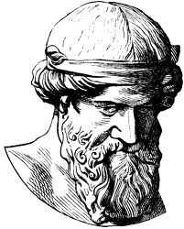
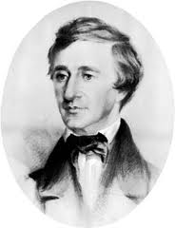
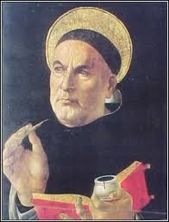
Wins _____
Losses_____

John Locke
1632-1704

Plato
429–347 B.C.E.

Ayatollah Khomeni
1902-1989

Henry David Thoureau
1817-1862

Benito Mussolini
1883-1945

Jean Jacques Rousseau
1712 – 1778

Thomas Hobbes
1588 –1679

Thomas Aquinas
1225–1274

Niccolo Machiavelli
1469 – 1527

Political Theorists
Philosopher Island’s Key Philosophers

These links are to help you understand your assigned philosopher and be prepared to argue his viewpoint in your “Philosopher Island: Meeting of the Minds.” The following men will be the featured people within your group.

John Locke additional links: I
Plato additional links: I II
Machiavelli summary of the Prince
Thomas Hobbes
Henry David Thoreau additional info: I Bio Civil Disobedience
Mussolini additional info: I Fascism
Jean Jacques-Rousseau additional info: I II

THEOCRACY – As run by Ayatollah Khomeni Start in the section labeled Life under Khomeini
Thomas Aquinas
You should start by creating an opening statement vodcast which exemplifies your character’s philosophies, highlights your key works, and gives your historical background and significance. Make sure you dress for your role.
Discussion Format:
Each student come in prepared with an opening statement which encompasses the:
- Character’s background information
- Key Phrases or terms associated with this person and their meaning
- Key Literary work which explains their viewpoint
- Basic Philosophy of this person relating to government
Also, you should fill out your own grid on the philosopher matrix form.

Discussions begin with students relaying their prepared opening statements and each group member is responsible for filling out their Philosopher Matrix.

Students will then decide which philosopher’s ideas will best solve a series of issues plaguing Philosopher Island. These issues will be provided by your teacher.

