Austria’s Path to Empire
A different path

As the rest of Europe became embroiled (all caught up in) in Nationalism in the 19th Century, three nations: Austira, Russia, and the Ottoman Empire maintained a multi-ethnic state. Is a national system the only path for the county? As time has passed, there have been two competing visions in this regard: unity versus nationalism. Europe has struggled in particular with this concept. Nationalism has brought great achievements to Europe, but also resulted in various bloody wars. Since World War II, in fits and starts, Europe has moved to a model of cooperation rather than Nationalism as demonstrated by the European Union (an economic association of over a dozen European countries which seek to create a unified, barrier-free market for products and services throughout the continent, as well as a common currency with a unified authority over that currency.) Take a look at the Austrian model over several centuries. When you have completed interactively reading this document. Write and answer three questions on the document’s content, and two critical thinking questions on the material.
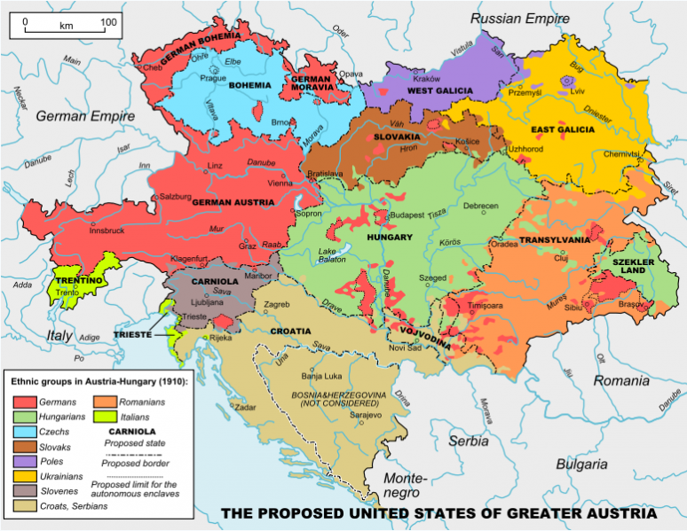
By 1278 the Habsburgs had gained control and this mighty dynasty managed to rule Austria right up until WW I. Although the Habsburgs were not reluctant to using a bit of muscle, they preferred less barbaric ways of extending their territory and so Austria gradually expanded thanks to sensible real estate purchases and many politically-motivated marriages.
New territories were acquired, which resulted in the Habsburgs, now also the Holy Roman Emperors, ruling much of central Europe including Hungary and Bohemia and Croatia, parts of Poland, Romania, Bulgaria, Italy, Ukraine, as well as the Netherlands and Spain and its vast overseas possessions. (The Empire was divided into a Spanish and Austrian half in 1556.) In 1571, when the emperor granted religious freedom, the vast majority of Austrians turned to Protestantism. In 1576, the new emperor, Rudolf II, embraced the Counter-Reformation and much of the country reverted, with a little force, to Catholicism. The attempt to impose Catholicism on Protestant areas of Europe led to the Thirty Years' War, which started in 1618 and devastated much of Central Europe. Peace was finally achieved in 1648 with the Treaty of Westphalia. For much of the rest of the century, Austria was preoccupied with halting the advance of the Turks into Europe.
Vienna nearly yielded to a Turkish siege in 1683 but was rescued by a Christian force of German and Polish soldiers. Incidentally, these long sieges of Vienna introduced coffee to Europe (from the Turks) and made Vienna famous for its coffeehouses.
The Habsburg Empire in its day was the only empire strong enough to ‘save’ Christian Europe from the Muslim Turkish forces conquering the continent. Even then, the Austrians needed aid from the Polish King Jan III Sobieski to rescues Vienna from Turkish seige.in 1683. consequently, Austrian forces under General Prince Eugene subsequently swept the Turks to the south-eastern edge of Europe. The removal of the Turkish threat saw a frenzy of Baroque building in many cities, and under the musical emperor Leopold I, Vienna became a magnet for musicians and composers.
In 1740, Maria Theresa ascended the throne and ruled for 40 years. This period is generally acknowledged as the era in which Austria developed as a modern state. During her reign, control was centralized, a civil service was established, the army and economy were reformed and a public education system was introduced. However, progress was halted when Napoleon defeated Austria at Austerlitz in 1805. Count Metternich was appointed minister of foreign affairs; a new chapter in the history of Austrian foreign and soon also domestic relations began. Metternich saw if Napoleon’s ambitious designs could be restrained, Napoleon would no longer be an enemy but as the barricade against new revolutions. Metternich believed Austria needed a breathing spell to recover from losses of wars and for wars later on, Austria should wait until a favorable bid was made and in that way the great power position could be secured by the pen before it was assured by the sword. Napoleon asked for the hand of Emperor Francis’ oldest daughter, Maria Louise. This marriage put a heavy strain on Austrian public opinion but Metternich thought it was a well worth risk to reconcile with Napoleon. European conflict dragged on until the settlement at the Congress of Vienna in 1814-15. After the Napoleonic Wars, Austria continued to be dominated by its king appointed chancellor, Prince Clemens von Metternich, who, by a combination of conflict and diplomacy, made the Austrian Habsburg Empire the leading power on the continent. Was Metternich a Success or Failure? You can judge for yourself by reading the article http://www.users.globalnet.co.uk/~semp/metternich.htm and answering the questions at the bottom. (That is for Extra Credit)

The Austrian Prime Minister Explains the Dual Monarchy
The multinational character of the Austrian Empire had long been a source of internal weakness and political discontent. After the defeat of Austria by Prussia in 1866, the Austrian government attempted to regain the loyalty of the Hungarians by making Hungary a separate kingdom within a dual monarchy known thereafter as Austria-Hungary

The dangers which Austria has to face are of a twofold nature. The first is presented by the tendency of her liberal-minded German population to gravitate toward that larger portion of the German-speaking people… the second is the diversity of language and race in the empire. Of Austria’s large Slav population, the Poles have a natural craving for independence after having enjoyed and heroically fought for it for centuries; while the other nationalities are likely at a moment of dangerous crisis to develop pro-Russian tendencies.
Now my object is to carry out a bloodless revolution- to show the various elements of this great empire that it is to the benefit of each of them to act in harmony with its neighbor… But to this I have made one exception. Hungary is an ancient monarchy, more ancient as such than Austria proper.
… I have endeavored to give Hungary not a new position with regard to the Austrian empire, but to secure her in the one which she has occupied. The Emperor of Austria is King of Hungary; my idea was that he should revive in his person the Constitution of which he and his ancestors have been the heads. The leading principles of my plan are… the resuscitation of an old monarchy and an old Constitution; not the separation of one part of the empire from the other, but the drawing together of the two component parts by the recognition of their joint positions, the maintenance of their mutual obligations, their community in questions affecting the entire empire, and their proportional pecuniary responsibility for the liabilities of the whole State. It is no plan of separation that I have carried out: on the contrary, it is one of closer union, not by the creation of a new power, but by the recognition of an old one…

Memoirs of Friedrich Ferdinand Count von Beust. Vol 1, ed. By Baron Henry de Worms (London: Remington, 1887). Pp xx-xxvi.
A stern autocrat, Metternich was taken by surprise by the 1848 rebellions in Europe, which forced many Royal houses to allow limited constitutional and social reforms. As nationalism swept across Europe, multinational empires like Austria seemed a thing of the past. Austria, however, as it seemed to do for centuries, found ways to adopt to the new situation and as some historians call it “muddle through”. Metternich resigned in the face of the peasant's revolt in Vienna, and the king introduced a parliamentary government. Despite the 1848 Revolutions, which hit Austria particularly hard (both liberals and peasants in Austria rebelled as did Nationalists in Hungary), the nation managed to regain control of its rebelling provinces and maintain a stranglehold of the German Confederation. (The confederation consisted of thirty-eight sovereign states and four free cities and included the five large kingdoms of Austria, Prussia, Saxony, Bavaria, and Wuerttemberg.)
In 1866 after being decimated in a brief war with the Prussians, the Austrian emperor was forced to rethink he relations with the Hungarians, who had had their liberties abridged after 1848, a process that concluded in the Ausgleich of 1867. In the new agreement, Hungary and Austria maintained separate parliaments, each with its own prime minister. The monarch had a common government which had responsibility for the army, the navy, foreign policy, and the customs union (economy). This agreement, while unwieldy, greatly strengthened the economies of all provinces and on the verge of WW1, appeared a stable and in the avenue of arts, culture, and religious tolerance a progressive influence within Europe. In 1914 the empire was economically strong and internally stable. Nor was the military a weak link. During the war Austria had fewer desertions than the Germans, fewer mutinies than the French or the Russians, and victories over Serb, Romanian and Italian Armies. Moreover, the works of recent economic historians such as David Good, John Komlos,and Richard Rudolph,among others, show that far from being a hopelessly economically backward state, the monarchy by 1914 had made impressive strides in terms of economic growth, even if the growth was uneven and intensified nationalism and nationality conflicts.
One controversy among historians remains: whether the Empire faced inevitable collapse as the result of a decades-long decline; or whether it would have survived in some form in the absence of military defeat in World War I.
- Alan Sked has advanced the view that, "to speak of decline and fall with regard to the Monarchy is simply misleading: it fell because it lost a major war." (The Decline and Fall of the Habsburg Empire 1815–1918)

The Austrian Empire has been viewed in two distinct ways by historians.
1. With the emergence of many small states from behind the Iron Curtain in 1989 there has been a significant nostalgia for the Austro-Hungarian monarchy and Emperor Franz Joseph in the lands of the former Habsburg empire. In 1989, the current head of the former ruling dynasty, Otto von Habsburg, was enthusiastically, even tearfully, cheered when, after the fall of the Communist regime, he returned to Budapest to meet members of the Hungarian parliament. Politicians and journalists in Europe and America now compare the old Habsburg monarchy to the disoriented East Central Europe of today (with countries intermeshed in Civil Wars & economic difficulties) and hold up the the Habsburg Empire as a positive model for supranational organization.For example, István Deák, in his highly acclaimed book Beyond Nationalism: A Social and Political History of the Habsburg Officer Corps, 1848-1918 (New York, 1990), strongly recommends (p. 9) that the "Habsburg experiment" in supranational organization be reexamined because "I am convinced that we can find here a positive lesson while the post-1918 history of the central and east central European nation-states can only show us what to avoid." London economist Alan Sked notes in The Decline and Fall of the Habsburg Empire, 1815-1918 that European statesmen would do well to ponder the history of the multinational empire for guidance on the problems involved "in ruling large numbers of people of disparate and often mutually hostile culture, in finding some bond of loyalty between them, and in retaining that loyalty in a world full of internal and external challenges."
2. Nationalist historians, on the other hand, tend to view the Habsburg polity as despotic and obsolete in the new era of nationalism.
In the Balkans, most of which were divided between the Ottoman and Habsburg Empires during most of the nineteenth century, nationalism emerged as part of the general discontent with the maladministration of the declining Ottoman Empire, or as a reaction against the changes within Austria-Hungary. The Austrian Empire simply couldn’t function as a country effectively given the numerous ethnic groups and grant each fundamental equality.

